Alternate rows in a report can be coloured using the Section Editor box in a crystal report

Create a report

Right Click on the report pane and choose Section Expert

In Details, Choose Color Tab(in the right pane)

[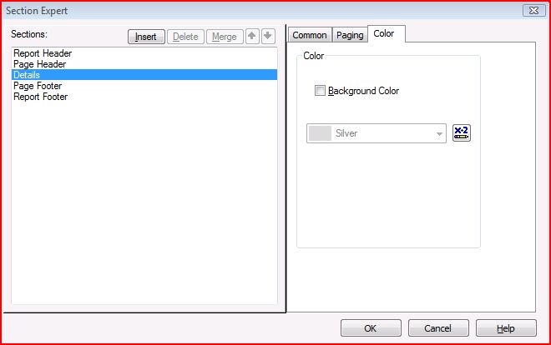](https://blogs.sap.com/wp-content/uploads/2012/10/capture_143633.jpg)

Choose the X-2 button to edit the formula to bring alternate row colourings

Edit the formula as ‘if recordnumber mod 2 = 0 then crTeal else crNoColor’

Save and Close the Formula window

The report gets reflected with alternate Teal and Plain colors